1: Install Git
Check version:
Command: git –version
Command: Sudo yum install git -y
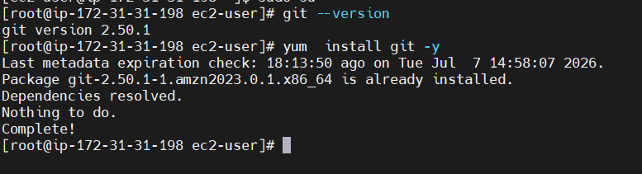

2: Create GitHub Repository with README.md and .gitignore
Steps
- Login to GitHub.
- Click New Repository.
- Enter repository name.
- Select Public.
- Check
Add README
Add .gitignore
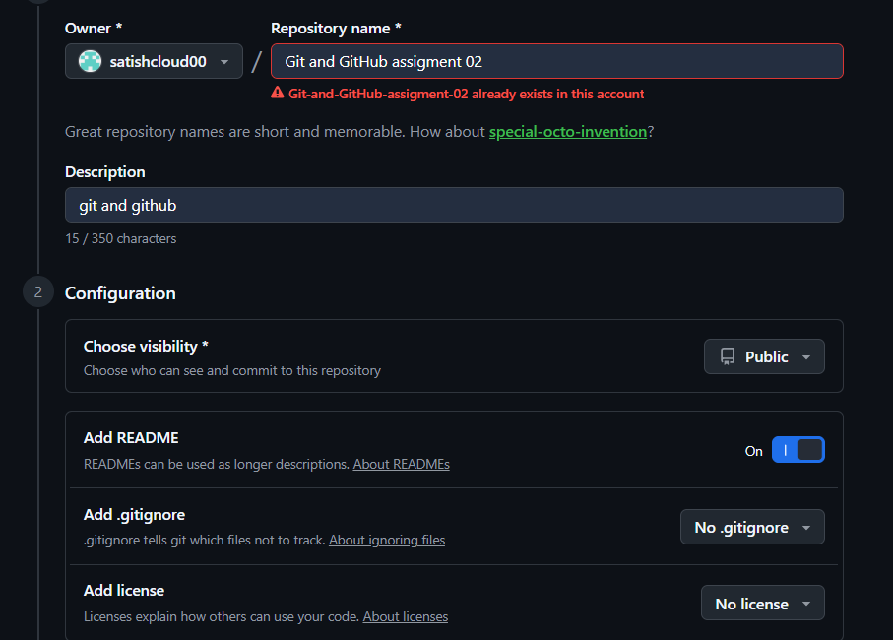

3. Clone the created repo to local. (GitHub to local)
Command : get clone https://github.com/satishcloud00/Git-and-GitHub-assigment-02.git
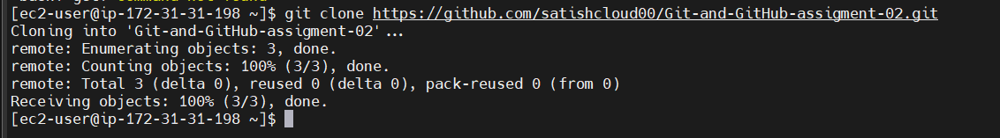
Move into repository
cd git-assignment 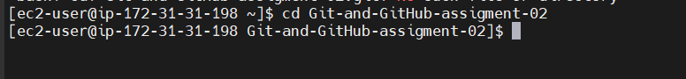
Git clone -Downloads repository from GitHub to local system.
Command : ls 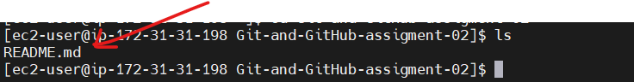

4.Create two files in local repo.
Command : touch git1 git2
To verify : ls
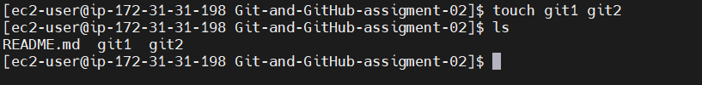

5. Commit two files and push to central Repository.
Step 1: check status of the 2 files e.g git1 and git2
Command : git status
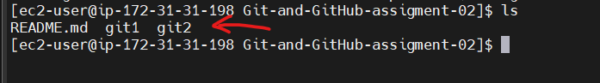
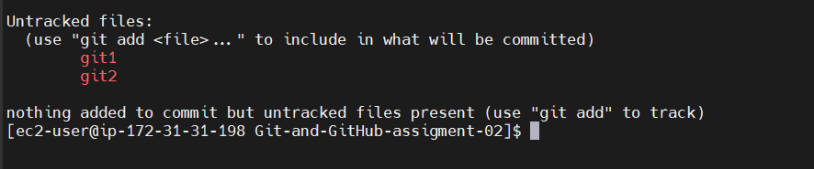
Step 2: we need to track 2 files by running git add .
Command : git add .
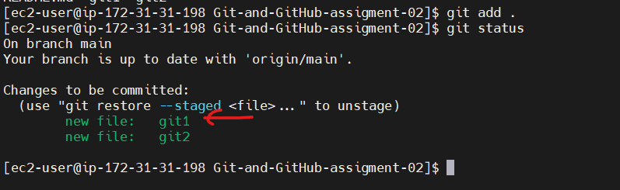
Step 3: now we need to commit the changes or Save changes locally.
Command : git commit -m “added git1 and git2 in git and GitHub assigment02” 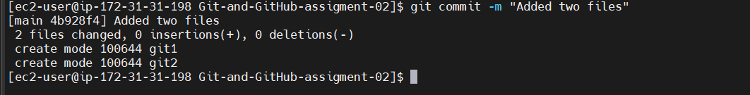
Step 4: Upload commits to GitHub.
Command : git push
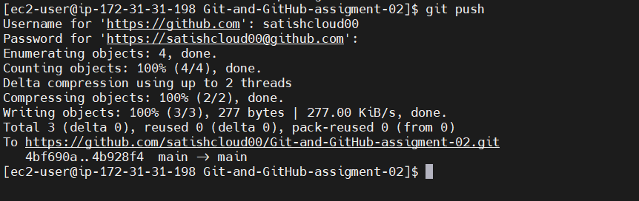
Go to GitHub and refresh the page
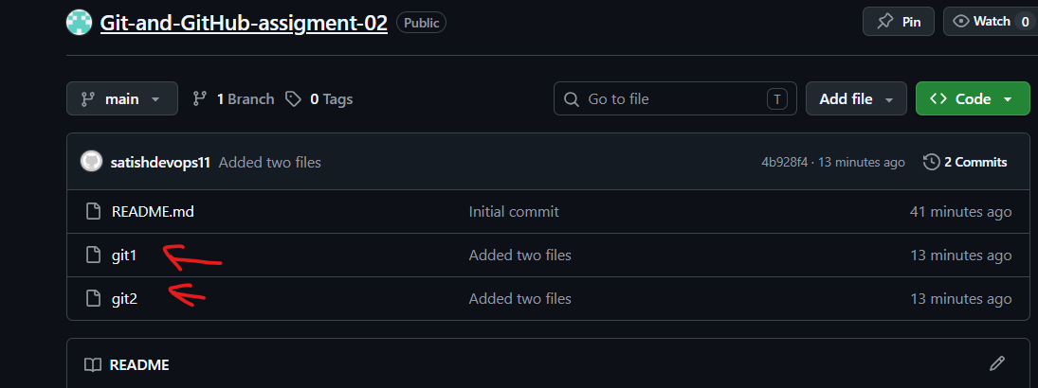

6.Create a branch in local and create a sample file and push to central.
Step 1: create branch in local
Command: git branch Release
To verify - git branch –list

Step 2: check which branch we are in and switch branch to Release
How check which branch we are just check *
*represents current branch
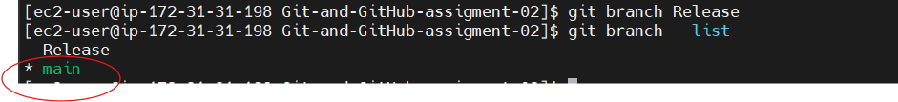
Step 3: switch branch from main to Release
Command : git checkout Release.
Now branch switched from main to Release
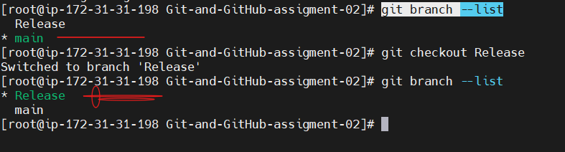

Step 4: create sample file in local machine
Command : touch sample.txt

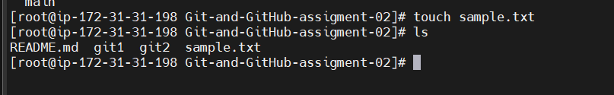

Step 5: now push from local to central
Command : git push
Before pushing we need to run 3 command :
Command : git status
Command : git add .
Command : git commit -m “sample.txt added to cetral”
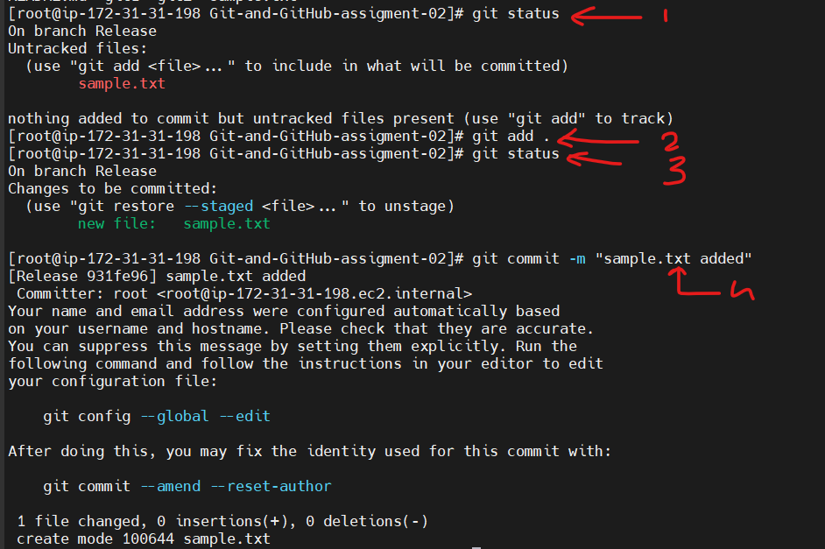

Now push to central
Command: git push
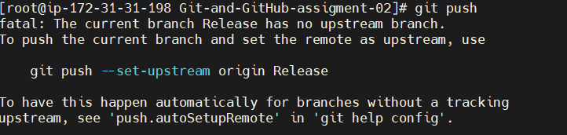
Git push now working so : Now we need to upstream branch using below command
Command: git push --set-upstream origin Release
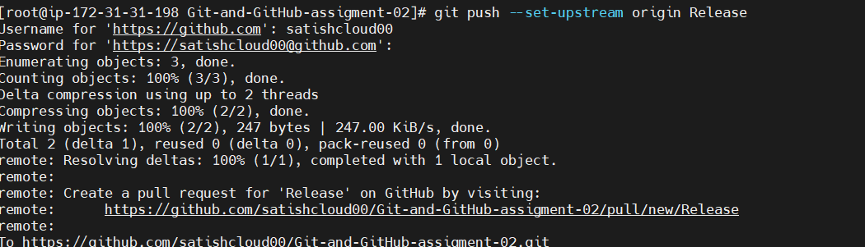

Refresh GitHub
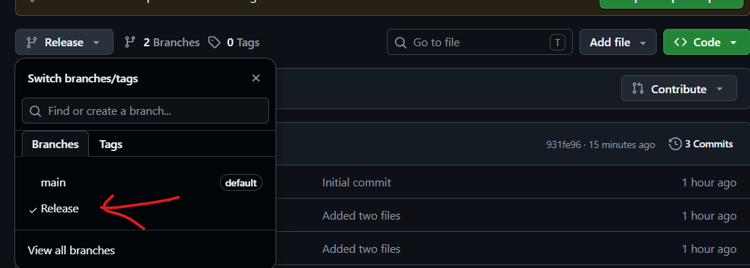

7.Create a branch in github and clone that to local.
Step 1: new branch created in GitHub” testing”
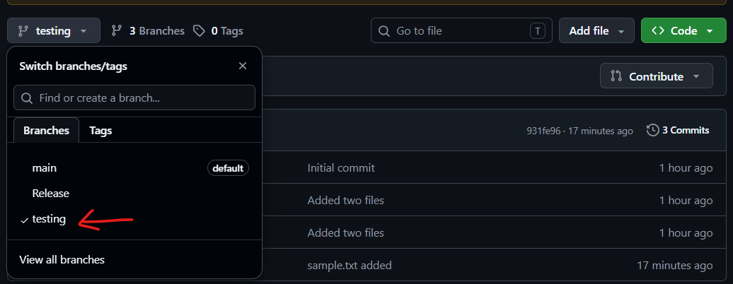
Step 2: download source code from central to local
Command : git clone git@github.com:satishcloud00/Git-and-GitHub-assigment-02.git
Command : git branch
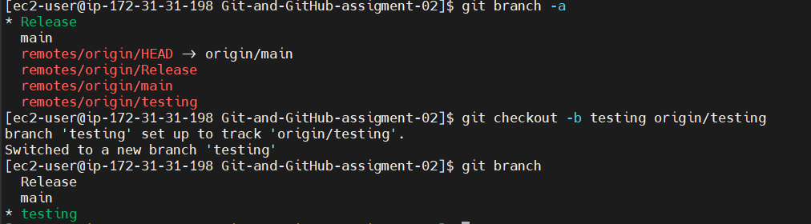

8.Merge the created branch with master in git local.
Step 1: Check your branches
Command : git branch
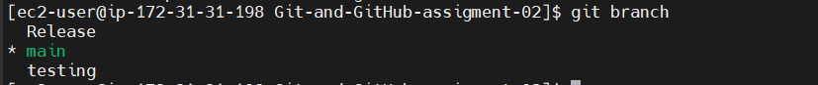
Step 2: Switch to the target branch (main)
Remember: Merge <source> into the branch you are currently on.
Command: git checkout testing

Step 3: Merge the testing branch into main
Command : git merge testing
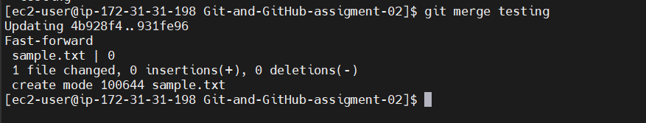
Step 4: Verify the merge
Check the commit history:
Command: git log --oneline

Step 5: Push the updated main branch to GitHub
Command: git push origin main
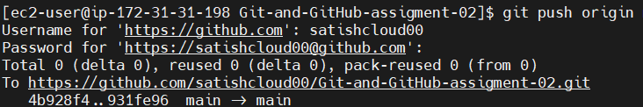

9. Merge the created branch with master in GitHub by sending a pull request.
Merge a Branch with main Using a Pull Request (Short Steps)
1. Go to your repository
cd ~/Git-and-GitHub-assigment-02
2. Check your branch
git branch 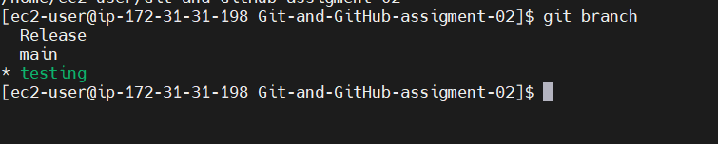
3. Check for changes
git status 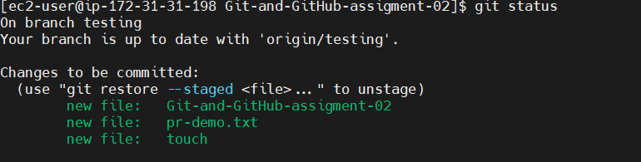
4. Add and commit (if there are changes)
git add .
git commit -m "Updated testing branch" 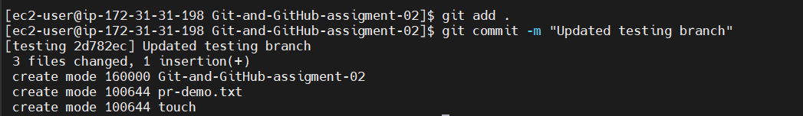
5. Push the branch to GitHub
git push origin testing 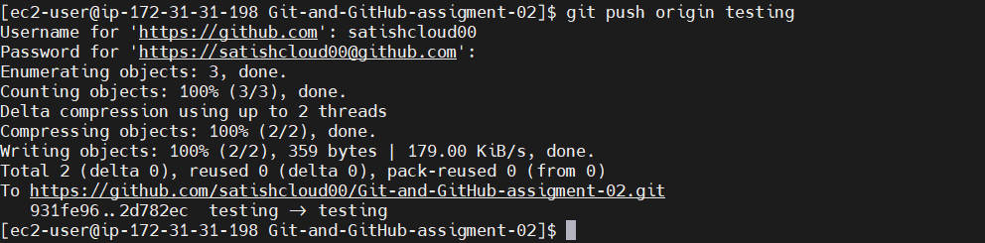
6. Open GitHub Repository
Go to your repository on GitHub.
7. Create a Pull Request
- Click Pull requests → New pull request
- Base: main
- Compare: testing
- Click Create pull request
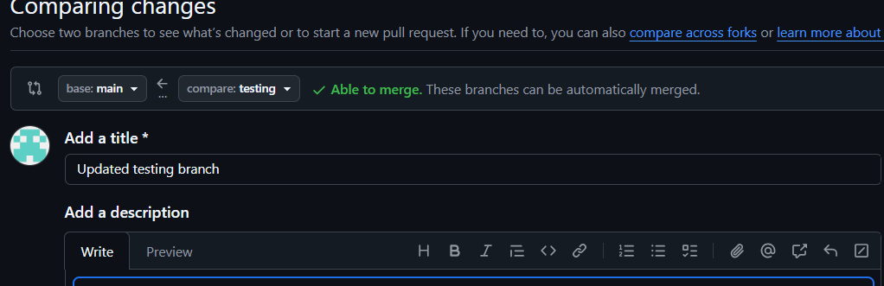
8. Merge the Pull Request
- Click Merge pull request
- Click Confirm merge 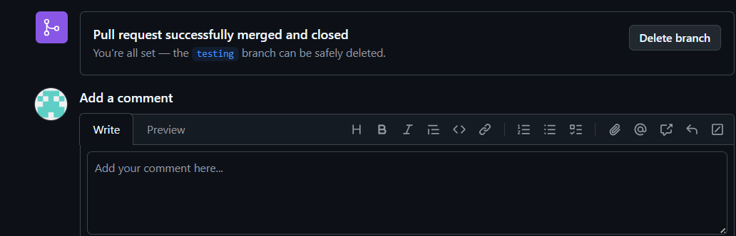
✅ Your testing branch is now merged into main.

10.Create a file in local and send that to branch in github.

Step 1: Go to your repository
cd ~/Git-and-GitHub-assigment-02
Step 2: Switch to the branch
git checkout testing
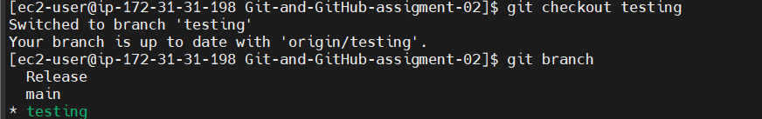
Step 3: Create a new file
touch demo.txt
Step 4: Add some content
echo "Hello GitHub" > demo.txt

Step 5: Check the changes
git status 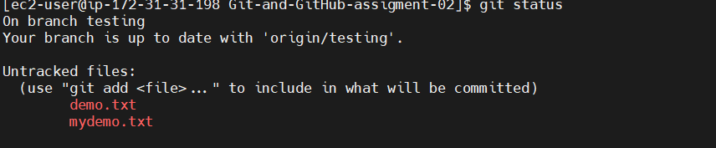
Step 6: Add the file and Commit the changes
git add demo.txt
git commit -m "Added demo.txt"
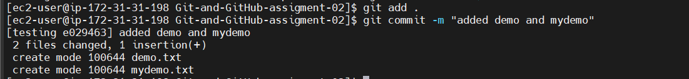
Step 7: Push to the GitHub branch
git push origin testing
✅ The demo.txt file is now uploaded to the testing branch on GitHub.
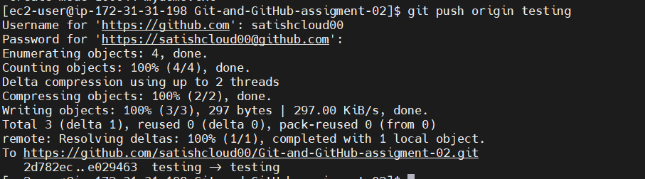
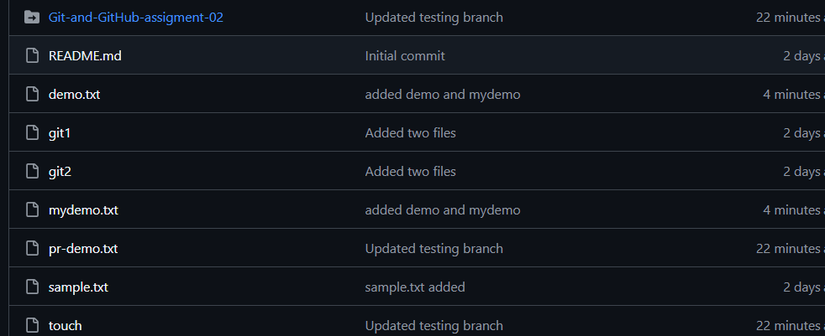

11.Clone only a branch from GitHub to local.
Step 1: Copy the GitHub repository URL
https://github.com/satishcloud00/Git-and-GitHub-assigment-02.git
Step 2: Clone only the required branch
git clone --branch testing --single-branch https://github.com/username/repository.git
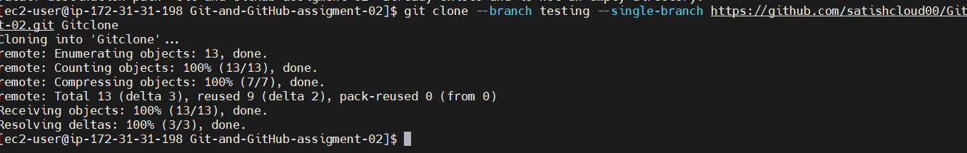
Step 3: Go to the cloned repository
cd repository

Step 4: Verify the current branch
git branch
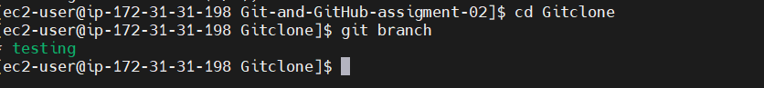

12.Create a file with all passwords and make that untrickable with git.
Step 1: Go to your repository
cd ~/Git-and-GitHub-assigment-02
Step 2: Create a password file
touch passwords.txt
Step 3: Add passwords
echo "admin123" > passwords.txt
echo "user456" >> passwords.txt
Step 4: Add the file to .gitignore
echo "passwords.txt" >> .gitignore
Step 5: Check the status
git status 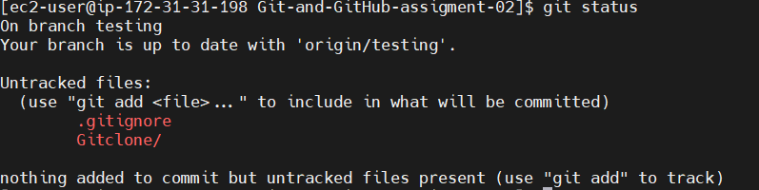

13.Make a commit and make that commit reset without savings changes.
Use git reset --hard.
Step 1: Go to your repository
cd ~/Git-and-GitHub-assigment-02
Step 2: Create or modify a file
echo "New content" > demo.txt
Step 3: Add the file and Commit the changes
git add demo.txt
git commit -m "Added demo.txt"
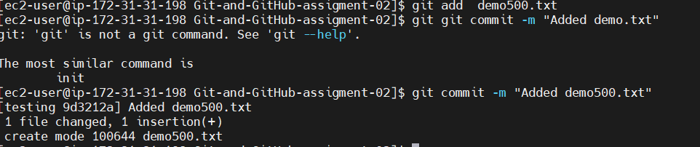

Step 5: Reset the last commit without saving the changes
git reset --hard HEAD~1
Step 6: Verify
git log --oneline
git status
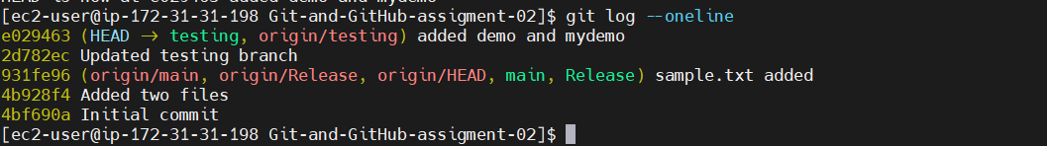
Result:
- ✅ The last commit is removed.
- ✅ The changes in demo.txt are also deleted (not saved).
Note: git reset --hard HEAD~1 permanently discards the last commit and its changes. Use it only if you are sure, you no longer need those changes.
14.Revert a commited commit to the older version.
Step 1: Go to the repository
cd ~/Git-and-GitHub-assigment-02
Step 2: Create a file
echo "Hello Git" > revert.txt
Step 3: Add the file and : Commit the file
git add revert.txt
git commit -m "Added revert.txt"
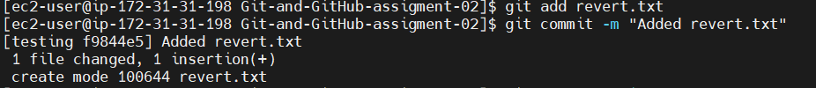

Step 5: View the commit history
git log --oneline 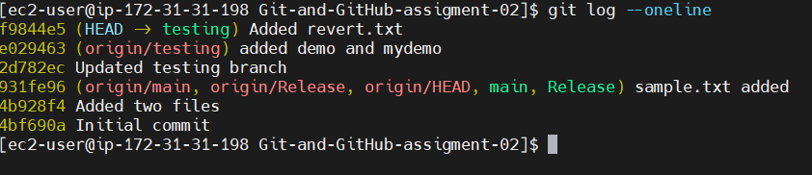
Step 6: Revert the last commit
git revert HEAD
Git will open the editor.
- Press Esc
- Type:
:wq
- Press Enter
Step 7: Verify
git log --oneline 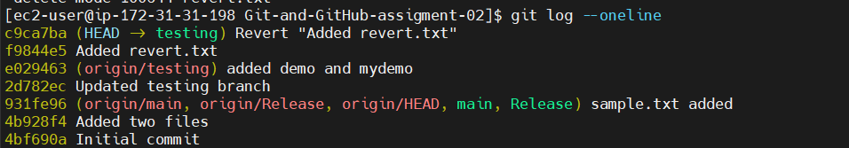

15.Push a file to stash without savings the changes and work on another file.
Step 1: Go to your repository
cd ~/Git-and-GitHub-assigment-02 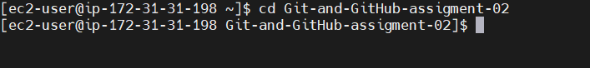
Step 2: Create a file
echo "My changes" > file1.txt
Step 3: Check the changes
git status
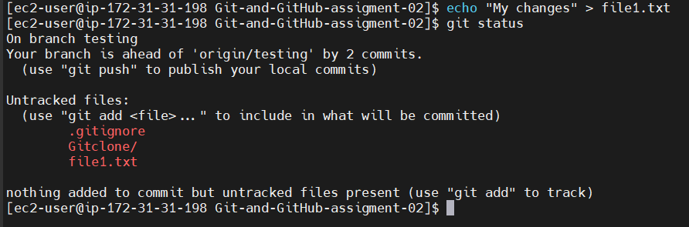
Step 4: Stash the changes (without committing)
git stash
Step 5: Verify the working directory is clean
git status 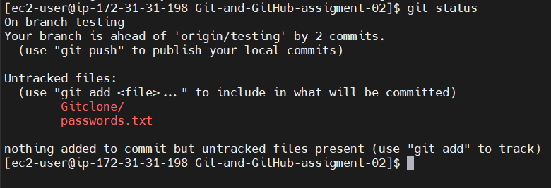
Step 6: Create and work on another file
echo "Working on another file" > file2.txt
Step 7: Check the status
git status 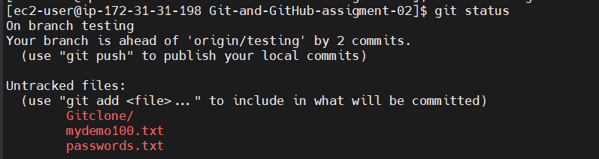
View the stashed changes
git stash list
Restore the stashed changes later
git stash pop 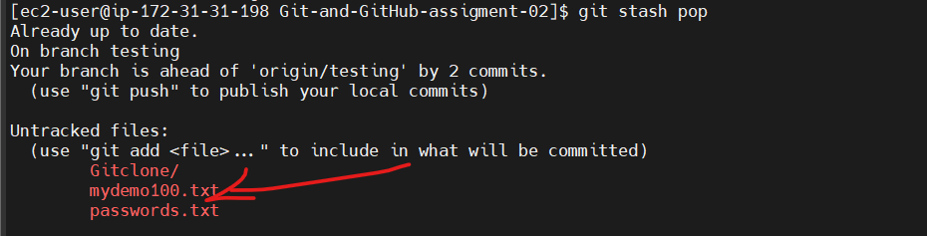

16.Undo the stash file and start working on that again.

To undo the stash and continue working on the file, use the following steps.
Step 1: Check the available stashes
git stash list 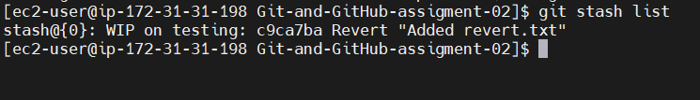
Step 2: Restore the stashed changes
git stash pop 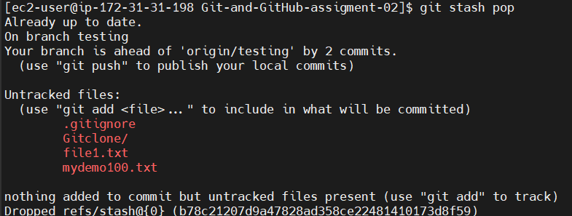

Step 3: Continue working
echo "More changes" >> file1.txt
Check the changes:
git status 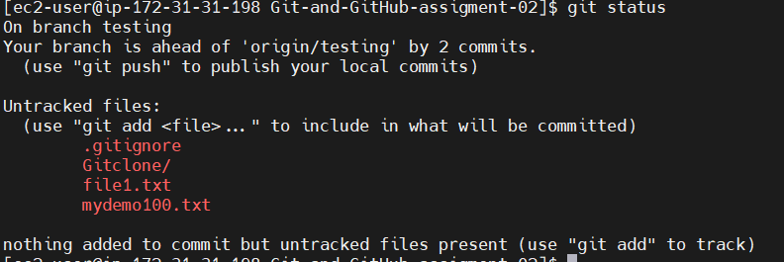

Commands for the assignment
git stash list
git stash pop
git status 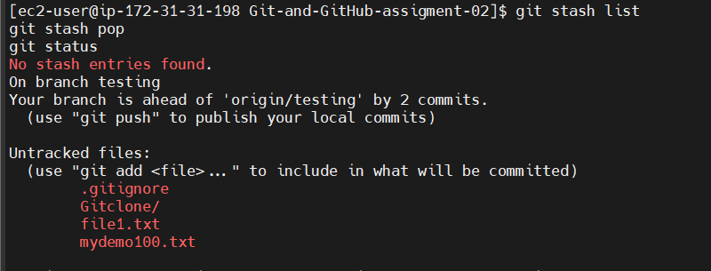

17.Generate a ssh-keygen and configure into github.
Follow these simple steps to generate an SSH key and configure it with GitHub.

Step 1: Check if an SSH key already exists
ls -al ~/.ssh 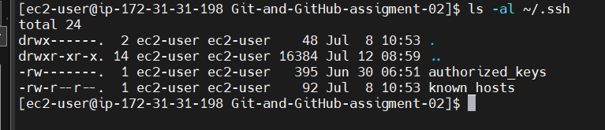
If you see id_ed25519 or id_rsa, an SSH key already exists.

Step 2: Generate a new SSH key
ssh-keygen -t ed25519 -C your_email@example.com
Press Enter for the default location:

Step 3: Start the SSH agent
eval "$(ssh-agent -s)"
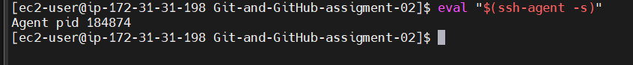

Step 4: Add the SSH key to the agent
ssh-add ~/.ssh/id_ed25519

Step 5: Display the public key
cat ~/.ssh/id_ed25519.pub 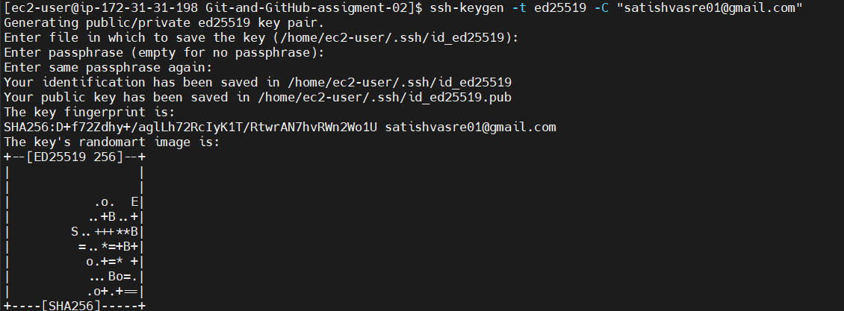

Step 6: Add the SSH key to GitHub
- Log in to GitHub.
- Go to Settings.
- Click SSH and GPG keys.
- Click New SSH key.
- Enter a title (e.g., EC2 Server).
- Paste the copied public key.
- Click Add SSH key.
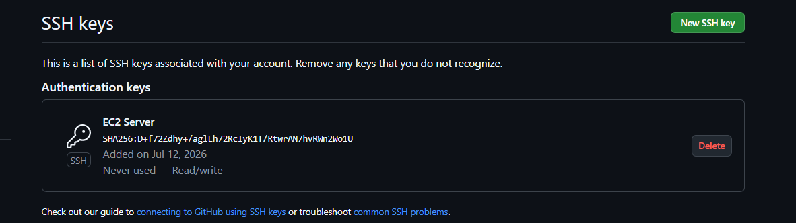

Step 7: Test the SSH connection
ssh -T git@github.com

Step 8: Verify the remote URL (optional)
git remote -v 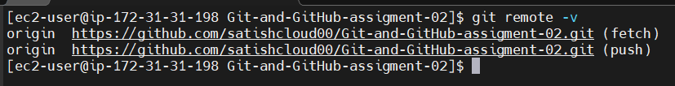
If it shows an HTTPS URL:
https://github.com/username/repository.git
Change it to SSH:
git remote set-url origin git@github.com:username/repository.git
Verify again:
git remote -v

18.Configure webhooks to github.
- Open your GitHub Repository.
- Click Settings.
- Click Webhooks (left menu).
- Click Add webhook.
- Enter the following details:
  - Payload URL: Your webhook URL (e.g., https://your-server.com/webhook or a testing URL like Webhook.site).
  - Content type: application/json
  - Secret: (Optional)
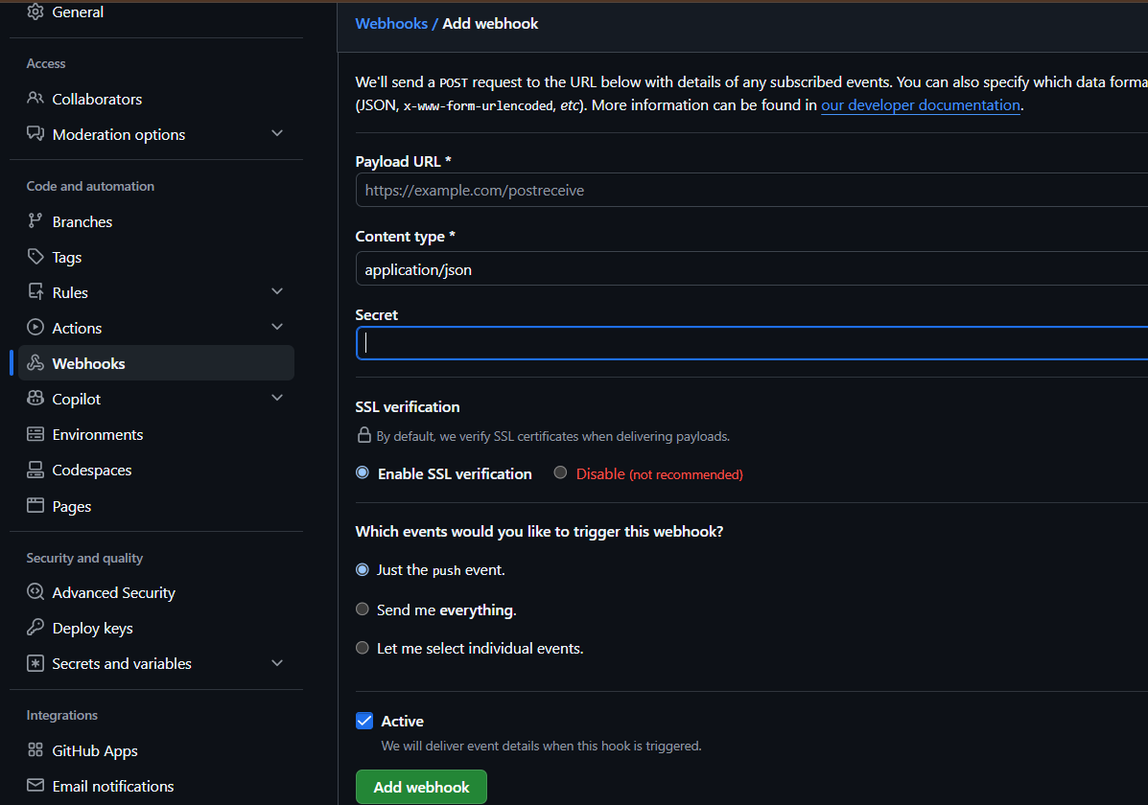
  - SSL verification: Enable SSL verification.

- Under Which events would you like to trigger this webhook?, select:
  - Just the push event (recommended).
- Click Add webhook.
- Test the webhook by pushing code:
echo "Webhook Test" > webhook.txt
git add webhook.txt
git commit -m "Webhook test"
git push origin testing
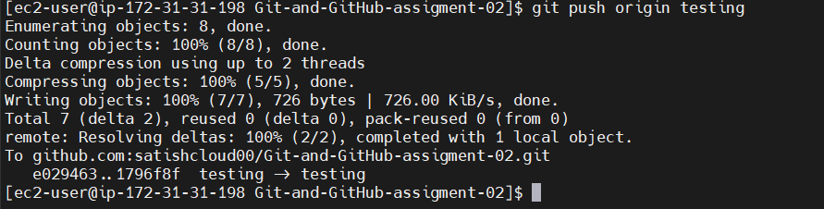

- Go back to GitHub → Settings → Webhooks → Recent Deliveries.

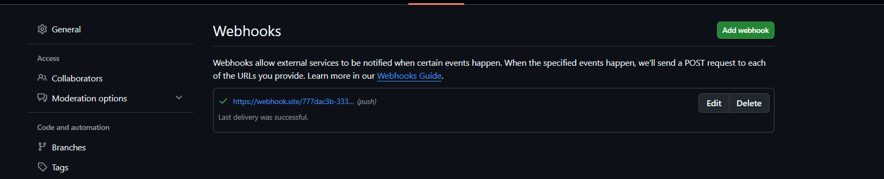
- Verify that the webhook shows a green check mark (200 OK), indicating it was triggered successfully.

19.Basic understanding of .git file.
Here is a step-by-step breakdown of how the .git folder tracks your project:
- git init Creates the Brain Initializing a repository creates a hidden .git folder containing configuration files (config), a pointer to your current branch (HEAD), and empty databases for your history (objects and refs).
- git add Prepares the Snapshot (Staging) When you stage a file, Git compresses its content and writes it into the objects/ folder as a "blob." It then updates the index file (the staging area) to map your file's path to that new blob.
- git commit Records the History Committing creates two more items in the objects/ folder:
  - A Tree object: A snapshot that mirrors your project's folder structure and links filenames to their respective blobs.
  - A Commit object: A small file containing metadata (author, date, commit message) and a pointer to the tree snapshot.
- References Move Forward Git automatically updates the file for your current branch inside refs/heads/ (e.g., refs/heads/main) to point to the hash of your brand-new commit object. Because HEAD points to your branch, it moves forward too.

20.Check all the logs of git.

Check All Git Logs (Step-by-Step)

Step 1: Go to your Git repository.
cd Git-and-GitHub-assigment-02

Step 2: View all commit logs.

git log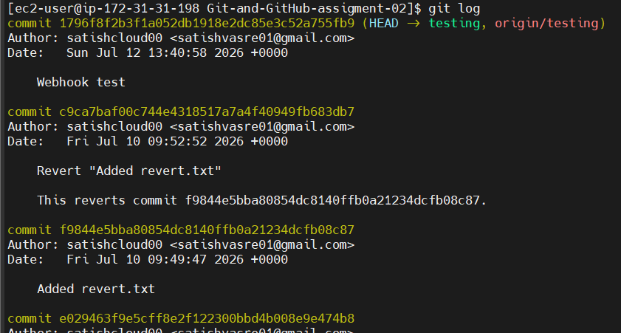
Step 3: View logs in one line.
git log –oneline
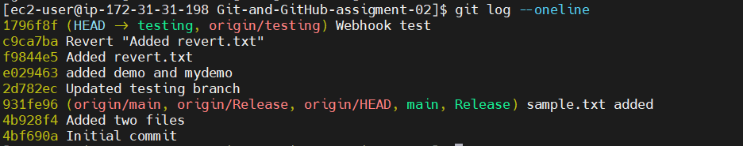
Step 4: View commit history with branch information.
git log --oneline --graph –all
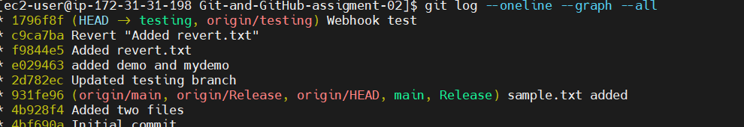
These commands let you see your Git commit history.

21.Rename the commit message.

Rename the Last Commit Message
Step 1: Rename the last commit message.
git commit --amend -m "New commit message"
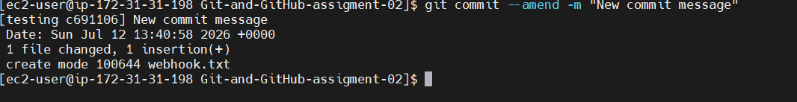
git commit --amend -m "Updated README file"
Step 2: If the commit was already pushed to GitHub, force push the changes.
git push --force origin testing 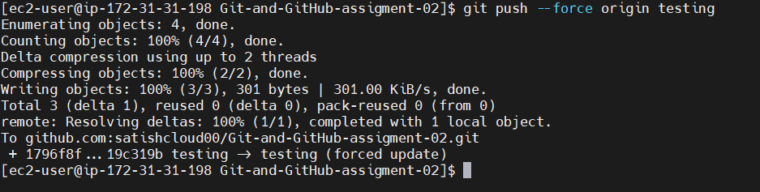
If the commit has not been pushed yet, only git commit --amend -m "New commit message" is needed.

22.Merge multiple commits into single commit.
Merge Multiple Commits into a Single Commit (Squash) – Step-by-Step
Step 1: Check the commit history.
git log --online 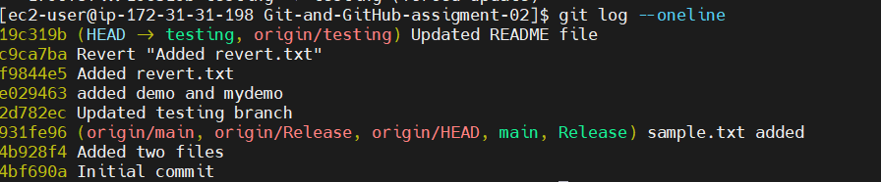
Step 2: Start interactive rebase (replace 3 with the number of commits to merge).
git rebase -i HEAD~3 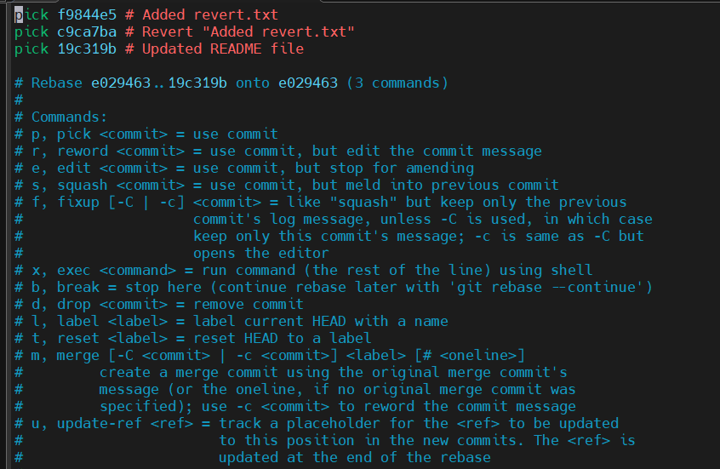
Step 3: In the editor:
- Keep the first commit as pick.
- Change the remaining pick to squash (or s).
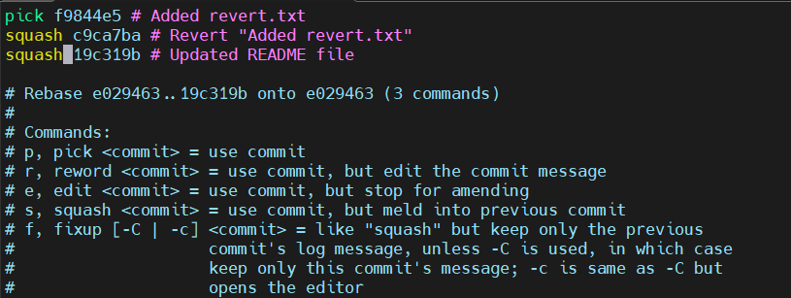

Step 4: Save and close the editor.
Step 5: Edit the commit message if prompted, then save and close.
Step 6: Verify the result.
git log --oneline 